

**1. Usman Qadeer:221370030**

**2. Qasim Riaz: 221370003**

**3. Waqas Rafique: 221370221**

**4. Rana Junaid: 221370126**

**Line Following Robot**

DLD(CS-135)

Submitted To: Engr Shaheer Saleem

**Line Following Robot.**

**Abstract:**

The Line Following robot is beginner-Friendly and interesting to understand and build. Its working consists of basic logic gates and circuits the robot basically going to follow a line and have to solve the maze of line. The robot consists of three IR Sensors to detect the line and two motors to control the movement and direction.

**Introduction**

Line following robot is a machine that follow a line. it is a robot which is capable of moving in the surrounding. Line following robot is actually a mobile robot which follow a provided path or trajectory through feedback mechanism and perform its own intelligence actions according to the path or obstacles present in front of it.

This robot consists of two DC motors and two wheels for movement, three IR sensors to detect the line, two AND gates, two OR gates, four NOT gates, one motor driver, a breadboard for circuitry, a car chassis for structural support, and two rechargeable cells for power.

This robot has capability to follow a black and dark path depending upon the contrast on lighter surface the line following robots have very wide range of applications ranging from normal domestic use to sophisticated industrial use such as a system that carries a package from one place to another in an industry following a predefined path.

**HARD WARE COMPONENTS:**

IR Sensors (3),

74LS08 IC (4 AND gate),

74LS04 IC (2 NOT gate)

74LS32 IC (2 OR gate)

L293N Motor Driver (1)

Dc motors (2)

Wheels (2)

Bread Board (01)

Jumper Wires

Chassis (01)

Caster wheel (01)

Recharge able cells (02)

**Working:**

Dc motors and wheels use for movement .**IR** sensors use to detect the line. Motor driver use to control the motors. Bread board used for circuitry. car chassis use for structural support and recharge able cells used to give the power of circuit

**Truth table:**

|  |  |  |  |  |
| --- | --- | --- | --- | --- |
| L(s) | C(s) | R(s) | M(L) | M(R) |
| 0 | 0 | 0 | 0 | 0 |
| 0 | 0 | 1 | 0 | 1 |
| 0 | 1 | 0 | 1 | 1 |
| 0 | 1 | 1 | 0 | 1 |
| 1 | 0 | 0 | 1 | 0 |
| 1 | 0 | 1 | 0 | 0 |
| 1 | 1 | 0 | 1 | 0 |
| 1 | 1 | 1 | 0 | 0 |

**Boolean expressions:**

M(L) = BC’ + AC’

M(R) = A’C + A’B

**Circuit:**

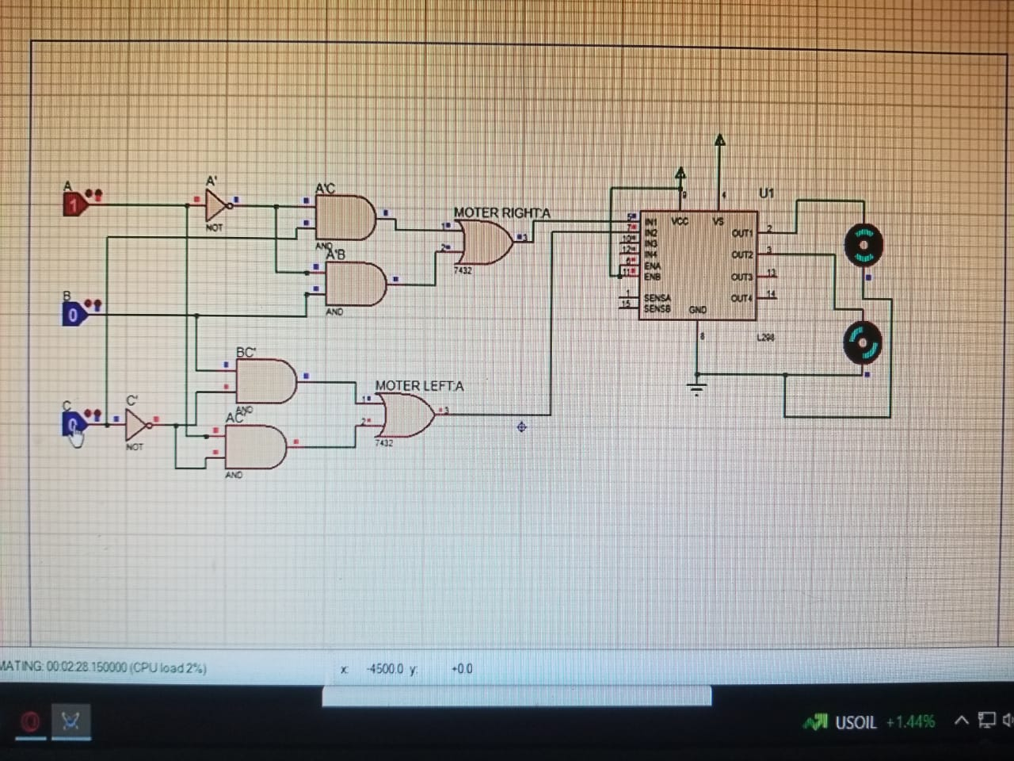

**Working:**

The line following robot works on simple logic consist of battery, 3 **IR** sensors, Two OR gates (74LS32), Two NOT gate (74LS04), and Four AND gates (74LS08) ,L298 motor driver working . The IR sensor give the output to the logic gate IC’s by detecting dark path

Then IC’s give high output when IR Sensors detect some infrared rays in front of it. Then motor driver (L298) who’s connected with Gates gives high output through high capacity rechargeable cells.

This is used as input signal to drive the motors. Since IR sensors are associated with motors we run the robot forward by driving all the motors and we can make turns by driving only two of the motors at the time.

**Hardware connections:**

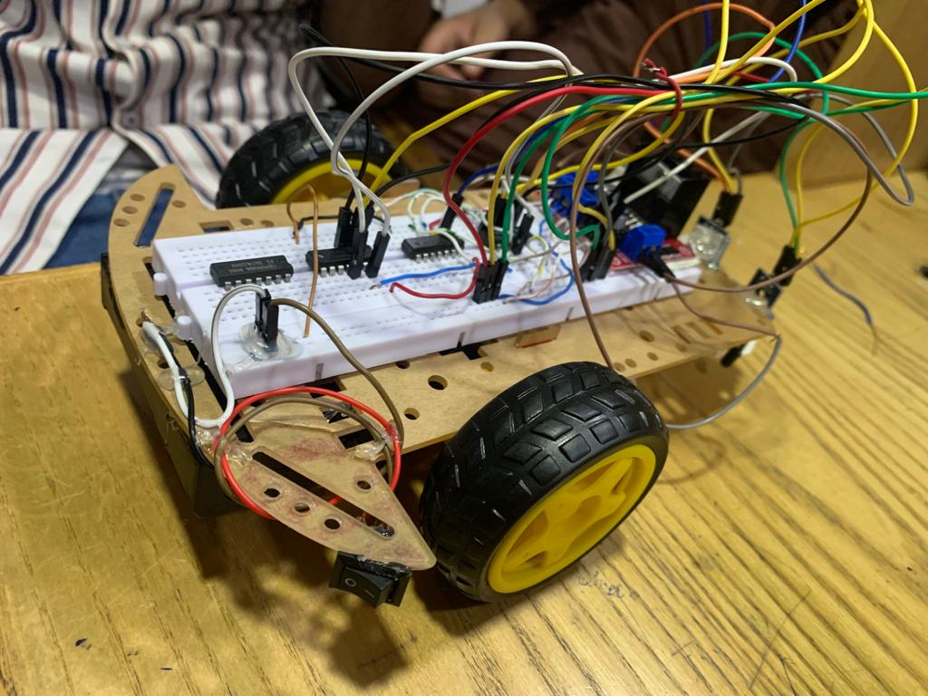

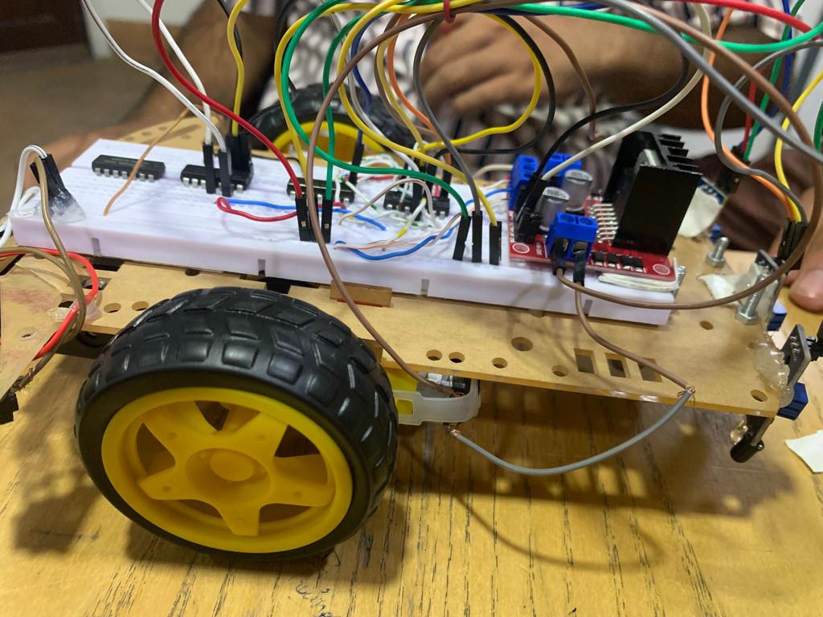

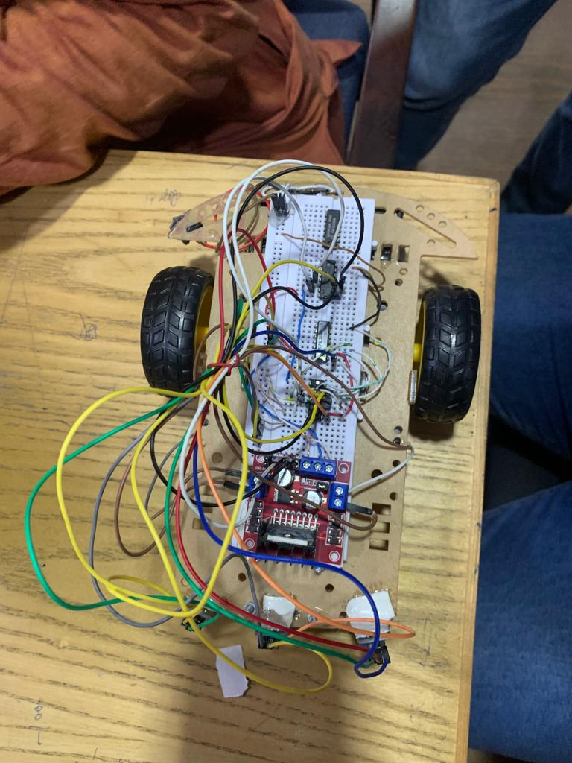

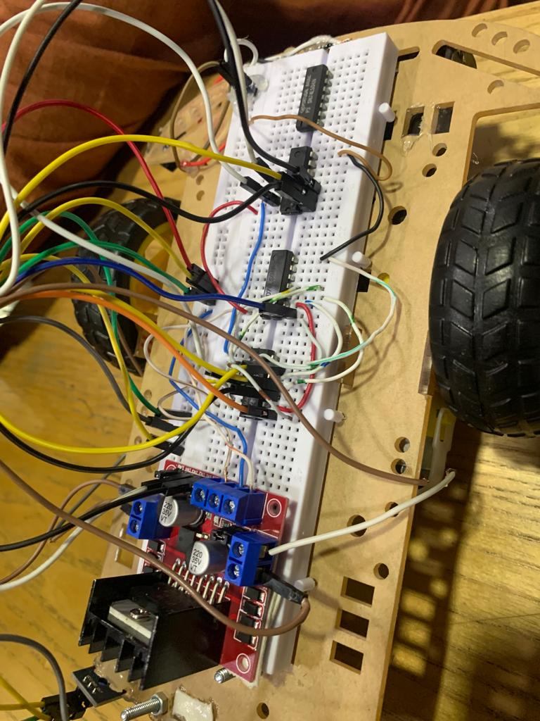

**Applications:**

* Line following robot is one kind of autonomous robot which follow a line.
* Line following robot is used for long distance applications.
* It is used for industrial automation and guidance system.
* These robot are used as automated equipment carriers in industries replacing traditional conveyer belts.
* These robots can be used as automatic cars running on roads with embedded magnets.
* These robots can also be used at homes for domestic purpose like floor cleaning.
* These robots can be used in public places like shopping malls museum etc. to provide guidance.

**Future scope:**

Industrial Automation: Line following robots can be used in various industries for automation purposes.

Agriculture: Line following robots can be utilized in agriculture for activities like crop monitoring, planting seeds, applying fertilizers, and even harvesting.

Line following robots can assist in healthcare facilities by transporting medical supplies, delivering meals to patients.

Line following robots can contribute to building smarter cities by performing various tasks like trash collection, street cleaning, or surveillance.

**Conclusion:**

Line following is a way of following robots to move autonomously in this project we came across the basic principle of logic gates and their implementations techniques which can be used for advanced project implementation. In this project we used the basic ideas of electronics for physical application. Motors are driven by H bridge motor driver. The circuit is designed in such a way that we are able to use advance application of this robot.